**Meeting notes are in reverse chronological order (most recent at the top)**

August 30, 2021

Student Meeting

**Attendance: Noor, Isabel, Ronel, Charline, Peter**

* Final tasks: presentation slides
* Add Skylight Analytics documentation
* Add a section about future work
* Finalize the case study

July 26, 2021

Student Meeting - Week 7

**Attendance: Noor, Ronel, Charline, Peter**

* Continuing to work on Tech Strategy
* Update on the UI

July 19, 2021

Student Meeting - Week 7

**Attendance: Noor, Ronel, Charline**

* Starting to work on Tech Strategy

July 9, 2021

Student Meeting with Deb- Week 6

**Attendance: Noor, Ronel, Peter, Isabel**

* Project purpose: how we can measure bandwidth across many applications
* Background on Deb
  + Director of Engineering at Intel
  + They work on creating chips that are used within networks
* Traffic Management for Best Effort Traffic
  + Network is frequently over-subscribed
  + Connection to the core-network is usually oversubscribed
* Traffic Management Objective
  + To unequally share the network resources (bandwidth and memory) between the users and applications
  + Traffic flows should be identified and classified in multiple queues to be able to control QoS.
  + Improving the user perspective of quality of service (QOS) is what we’re trying to achieve, and it’s super important
  + Network protocols and architectures such as IntServ, DiffServ, and MPLS help us to provide QoS in the network.
  + QoS seeks to specify and control 5 fundamental network variables
    - Bandwidth or throughput
    - Latency
    - Jitter
    - Packet loss
      * How much of the peak capacity is actually being used
    - Link availability
* Traffic Shaping
  + Controls the rate at which packets are sent (not just how many)
    - This is a good way to control how much bandwidth a user is receiving based on how much they’ve paid without letting them pass the limit
  + At connection set-up time, the sender and carrier negotiate a traffic pattern (shape)
  + Two traffic shaping algorithms are:
    - Leaky bucket
      * Enforces a constant output rate regardless of the burstiness of the input
      * Does nothing when the input is idle
      * When a host uses leaky bucket traffic management, it injects one packet per clock tick onto the network. This results in a uniform flow of packets, smoothing out bursts and reducing congestion.
      * Constant output rate (configurable or non-configurable) and the size of the bucket itself
    - Token bucket
      * One token is added to the bucket over a time interval
    - Differences:
      * LB discards packets and has more direct access output whereas TB doesn’t discard packets and has a direction-pointed output
      * With TB, a packet can only be transmitted if there are enough tokens to cover its length in bytes.
      * LB sends packets at an average rate. TB allows for large bursts to be sent faster by speeding up the output.
      * TB allows saving up tokens (permissions) to send large bursts. LB doesn’t allow saving.
* Traffic Marker
  + You start with a packet arrival
  + You then check to see if there are enough buckets
    - If yes, then mark it as green
    - If no, then mark it as red
      * If red, then those packets are either dropped or buffered for later transition
  + After making the packets, they move forward into processing
* Congestion Control
  + End to End Congestion control may result in global synchronization
  + The source takes action only after congestion actually occurs
  + Drop-tail routers (once the queue is filled, drop all incoming traffic) are biased against bursty traffic
  + Transient and persistent congestion isn’t distinguished
  + Gateway has no say in congestion control
* Questions
  + How do we decide which bucket algorithm to use?
    - Unless we’re dealing with a very simple method, we should use TB.
    - Make sure you understand LB really well if you’re going to use TB.

July 6, 2021

Student Meeting- Week 6

**Attendance: Noor, Ronel, Charline, Peter, Isabel**

* Issue: Team members can’t access the cloned the Anvil app through the Git repository
  + Noor and Isabel will further test it out
* Task: Go through the to-dos of making a “hello world” app on Anvil
  + Make sure you’ve created an Anvil account and joined Ikhlaq’s workspace

June 29, 2021

Student Meeting- Week 5

**Attendance: Noor, Ronel, Charline, Peter**

* Peter and Charline: work on UI (update)
* Ronel: Work on design Document (update)

June 25, 2021

Student Meeting- Week 5

**Attendance: Noor, Ronel, Charline, Peter**

* Peter and Charline: work on UI
* Ronel: Work on design Document

June 15, 2021

Meeting with Ikhlaq - Week 4

**Attendance: Ikhlaq, Noor, and Isabel**

* Slide 3: Unclear about exactly what is wanted
  + Automatically adjust the bandwidth (nodes, thickness of links, etc.) to different “optimal” amounts throughout the day depending on network traffic
  + Characterize the application traffic on any link
* Slide 4: dynamically set bandwidth to some optimal value
  + Turn this into the purpose of the project slide and maybe skip slide 3
* Slide 6: Think about why the second box is circled and the others aren’t (explain it so people aren’t confused)
  + They have other projects going on and this is what we’re focusing on
* Slide 8:
  + Diagram Ikhlaq drew
* Slide 9:
  + 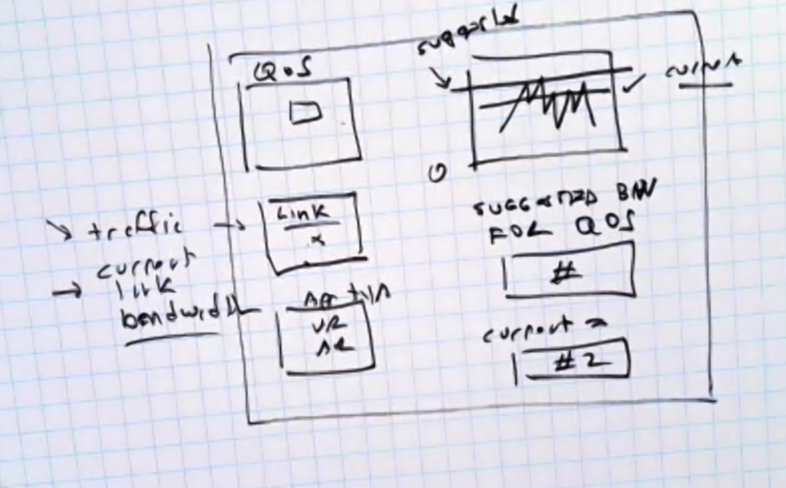

June 14, 2021

Student Meeting - Week 4

**Attendance: Charline, Noor, and Isabel**

* Improve [Innovation-X Slides](https://docs.google.com/presentation/d/1l3UgqgrCgx1Q7vzJlGr-ny37KQWop7xGx7I3zuFOwhY/edit#slide=id.gddb5253485_1_0) by Tuesday night
* Add axes to all of the graphs you create
* Read the speaker notes on slide 9 about all the components Valery wants to see:
  + 1. changing bandwidth: line plot (bandwidth on y axis and time on x axis)
  + 2. analytics (real time effect on data): bell curve for stats and print out analytics in dataframe
  + 3. kpi
  + 4. remote connection to client : check responsiveness
* **Task for Ronel:** For the second graph on slide 10 (bandwidth vs. time), can you please narrow the time down to a day or a couple of days to
  + Title it “Changes in Bandwidth in Hours on *insert day(s)*”
  + Label the axes: x=bandwidth, y=time (hours)
  + Do .describe() on the data you use to print out the stats of the data set (sd, mean, variance, etc.)
* **Task for Charlene:** make a table called “Characterization of Packet Loss” to go below everything
  + Use .describe() to get the mean, median, variance, SD
* **Task for everyone:** complete and upload UI components into Innovation-X Seminar slides by Tuesday (6/15)
  + Make sure to have axes on all graphs
  + Follow Valery’s guidelines from above (at least one of the 4)^

June 11, 2021

Student Meeting - Week 3

**Attendance: Charline, Noor, Ronel, and Isabel**

* Seminar next Wednesday (6/16) from 10-11am PT
* Improve UI component in **Innovation-X Seminar** by next Monday (1/14)
  + We made a copy of the Low Tech Demo slides called Innovation-X Seminar, so please make your edits in the new copy.
  + Reach out to all team members to work together if helpful and ask Noor and Isabel any questions.
  + Slide 4 is a description of slide 8’s drawing.
  + Develop another UI that would best visualize Phase 1 and Phase 2 on Slide 4 based on what Ikhlaq described on Thursday (more description about that in Colt meeting notes).
  + For example, on slide 8, you can see how Ikhlaq drew a horizontal line for the bandwidth threshold/limit and any part on the curve that passed that line was considered a packet loss, delay, or jitter. Please recreate a UI/graph with a horizontal line (like the one on slide 8) with a legend, title, axes, etc. Since this is for our presentation on Wednesday, please write a description about what the graph represents.
* Account info for Colt on Demand
  + Isabel will send out the account info and password next week! Colt is currently fixing something in the account, so we’re not allowed to use it until then.

June 9, 2021

Student Meeting - Week 3

**Attendance: Noor, Isabel, Peter, and Ronel**

* Played around with Streamlit for network traffic analysis:
  + Computer Network Traffic Kaggle Dataset: <https://www.kaggle.com/crawford/computer-network-traffic>
  + [Using Streamlit to build an interactive dashboard for data analysis on AWS](https://aws.amazon.com/blogs/opensource/using-streamlit-to-build-an-interactive-dashboard-for-data-analysis-on-aws/)
  + Github repo: <https://github.com/aws-samples/streamlit-application-deployment-on-aws>
  + Streamlit [Documentation](https://docs.streamlit.io/en/stable/getting_started.html#draw-a-line-chart)
  + Streamlit [cheat sheet](https://share.streamlit.io/daniellewisdl/streamlit-cheat-sheet/app.py)
  + Streamlit [Charts API](https://docs.streamlit.io/en/stable/api.html#display-charts)
  + [How to create and deploy data exploration web app easily using Python?](https://medium.com/@ansjin/how-to-create-and-deploy-data-exploration-web-app-easily-using-python-a03c4b8a1f3e)

June 7, 2021

Student Meeting - Week 3

**Attendance: Noor, Isabel, Andy, Charline, Peter, and Ronel**

* UI component ideas:
  + Company called Solar Winds -> IT management
    - <https://www.solarwinds.com>
  + Pie charts for the proportion of bandwidth usage for each application
  + Peter’s google doc: <https://docs.google.com/document/d/1dlVMsCl9lYi53MfNvkcrI2z7b614YUZyYo_GhAeW5cM/edit>
  + Print out packet loss
  + Look into Streamlit: <https://streamlit.io>
  + Print out analytics in a table or dataframe
  + Add bandwidth amount on y axis and time on x axis

June 2, 2021

Student Meeting - Week 2

**Attendance: Noor, Isabel, Andy, Peter, and Ronel**

* Shared/reviewed updates from Week 2 Colt meeting
* Next steps
  + Research (Isabel)
  + Technical concepts
  + Technical demo of MVP (Noor)
    - UI Component (Charline, Andy, Peter, and Ronel)
* If you’re working on the project at a specific time, then create an event on the google calendar (i.e. “Isabel 8-9am”) so that anyone else who is working at the same time can see it and join/work with you.
* Feel free to use our student zoom link (on Notion) at any time to work on the project! We’re all co-hosts, so you can hop on at any time.

May 31, 2021

Meeting with Elisa

**Attendance: Isabel and Noor**

* Meetings potentially on Thursday mornings with the entire team
* Add more channels on Slack to make it easier to separate groups/know where to find messages
* Colt team might be unavailable due to holidays between July and August, so check as much as you can from now on.
* Focus on one application or really narrow it down since telecommunications are very complicated.

May 28, 2021

Student Meeting - Week 1

**Attendance: Noor, Isabel, Andy, Charline, Peter, and Ronel**

* Meetings will be held through Zoom
* Slack is our main communication platform
  + Please check regularly (at least once every 24 hours) in case there are any important messages or announcements
  + We encourage everyone to work collaboratively and ask lots of questions!
* Schedule weekly meeting times
  + When2meet: <https://www.when2meet.com/?12002492-HA2od>
  + Student group: Monday or Tuesday between 7-9am PDT
  + Colt team:
* NABC Innovation Navigator Slides (introducing Need, Approach, Benefit, and Competition aspects of the project)
  + <https://docs.google.com/presentation/d/1ujTwOoxoaDOBa2V1Kpdz611Lu9gEXhaXp0kxunxos3g/edit?usp=sharing>
  + Questions for Colt regarding competition: What systems does Colt have in place now?
* Low Tech Demo Template
  + <https://docs.google.com/presentation/d/1d-Ue2aZshReTX-nVUDWiQ14WTXoGgZRHgL_ThF-JjqI/edit?usp=sharing>
* Notion
  + <https://www.notion.so/Colt-X-Project-7984d472ee644a62a70269382da7191c>